Table of Contents

Table of Contents
1. Allow CSU GE Area D without subareas (by Fall 2016) 2
2. Allow IGETC Area 4 without subareas (by Fall 2016) 2
3. Change Transcript View to show four character SSN 2
4. Add CCC-ID (OpenCCC) Student ID# to Transcripts 3
5. Add C-ID to Transcript Data and Views – Issue #2399 4
6. eTransCA_CO2010-04_DownloadOneTranscriptPerFile_Issue2288 6
7. eTransCA_CO2011-01_ DeleteExpiredTranscript_Issue2326_v1-3 6

Allow CSU GE Area D without subareas (by Fall 2016)

Problem Statement

CSU System will be removing subareas from GE Breadth ‘Area D’. Currently eTranscriptCA is required to have subareas.

Solution Request

Change the edit validation within eTranscriptCA to allow only Area D without subareas.

Allow IGETC Area 4 without subareas (by Fall 2016)

Problem Statement

UC System will be removing subareas from Social Sciences ‘Area 4’. Currently eTranscriptCA is required to have subareas.

Solution Request

Change the edit validation within eTranscriptCA to allow only ‘Area 4’ without subareas.

Change Transcript View to show four character SSN

Problem Statement

eTranscriptCA Full View online and printed show full SSN. This could be a security issue. While full SSN is needed within the data allowing all eTranscriptCA Control Center users to have access to full SSN may not be desirable.

Full View: with full SSN showing
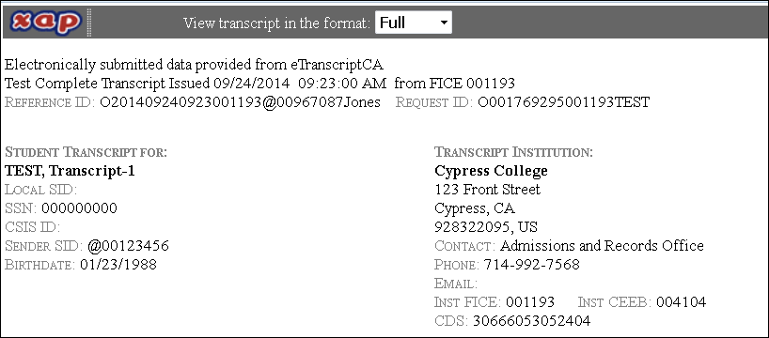

Gen Ed View with no SSN showing:
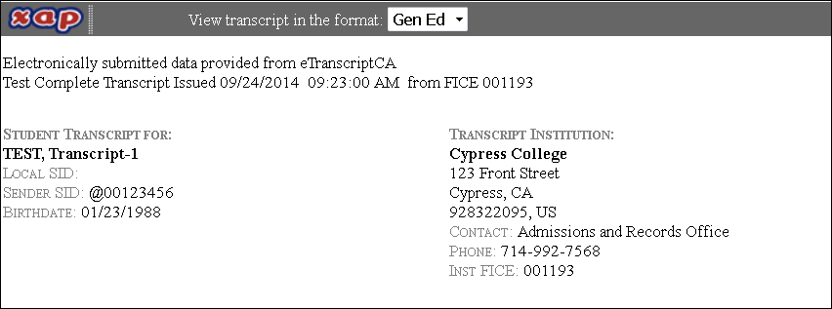

Brief View with no SSN showing:
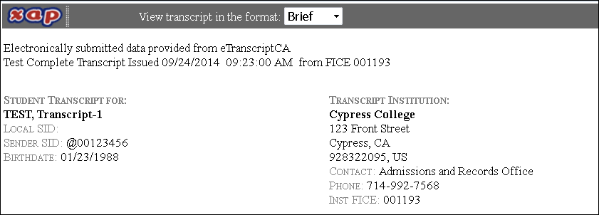

Solution Request

Three options:
- Do nothing
- Enable role based access to view full SSN on the Full View and prevent printed output of that view.
- Eliminate full SSN from all views and printed output. Change all views to incorporate the last (4) four numbers of the SSN.

Add CCC-ID (OpenCCC) Student ID# to Transcripts

Problem Statement
Students applying for community college use the CCCApply.org website. This site will then create a new unique student ID known as their CCC-ID. This unique identifier will unite the student with all their records available through this site.
This identifier is becoming more important and should be included in the data transfer for eTranscriptCA transcripts.

Solution Request
Add CCC-ID to eTranscriptCA data transcript files.
- This value is 8 characters A/N
- Field would be added to the Student Identity record in the transcript ASCII file for uploads
- Field would be added to the Student Identity record in the transcript XML file for uploads
- Mapped to EDI and XML according to existing student identity information
- Would be included in all transcript data downloads (EDI, XML, ASCII)
- Brief view – display last 4 characters
- Gen Ed view – display last 4 characters
- Full view – display last 4 characters
- Printed according to transcript views

Add C-ID to Transcript Data and Views – Issue #2399

Problem Statement

The Course Identification Numbering System (C-ID) is an intersegmental effort to address the need for a “common numbering system”. C-ID is a voluntary, supra-numbering system that responds to legislative mandates and the expressed needs of California’s higher-education providers. The C-ID program has been active over five years, presently over 80 community colleges collectively have over 2,000 courses among 301 active descriptors covering 31 difference disciplines that have been granted C-ID designation.

C-ID is a statewide numbering system independent from course numbers assigned by local colleges. A C-ID designator next to a community college course allows participating community colleges to identify courses offered by other campuses as comparable in content and scope to a course offered on their own campus that shares the same C-ID designation, regardless of unique college course numbers. Thus, if a catalog or schedule of classes lists a course bearing a C-ID designation, students on one campus can be assured that it will be accepted in lieu of the comparable C-ID course noted in the catalog or schedule of another campus. For example, C-ID PSY 110 on one campus will be accepted as meeting the requirement of the designated C-ID PSY 110 course at the other participating California community college. The CSU is also working to identify which of their courses will accept a certain C-ID descriptor, and when so, any community college course that shares the same C-ID number will meet the requirements of that CSU course. Currently about 1400 CSU courses have matching C-ID descriptors.

Solution Request

C-ID’s most immediate goal is to increase articulation – at a time when more and more of California’s transfer students are likely to be accepted at a university or college other than that which they had intended. The capability for counselors and evaluators to review a transcript(s) which lists C-ID courses adjacent a college course, when applicable, is essential for assisting the evaluation of a CCC student’s activity between CCC colleges as well as a student’s preparation for transfer to universities which have courses accepting C-ID designated courses. Additionally, C-ID course designation use will continue to become more prevalent as C-ID numbers are a required element of the SB 1440 associate degree for transfer program.

C-ID designation represent a concatenation of up to four fields, as follows:
- Discipline Id (4A, required)
- Sub-discipline Id (4A, optional)
- Number (5 digits, required)
- Suffix (5A, optional)

A few examples of C-ID designators, as follows:
- AG-AS 156L (Animal Breeding and Production, with a lab). This example uses all four fields.
- CHEM 100 (Chemistry and Society). This is a simpler example which does not use the optional fields.

Proposed Data Fields for C-ID
- Details would be at the course level by term (Fall 2011 / ANTH 310)
- Include C-ID Designator (i.e. ANTH 120)
- Include C-ID Descriptor Name (ANTH 120 Introduction to Cultural Anthropology)
- Include C-ID Descriptor Approval Date
- Include Course of Record Effective Term (COR)

Logic for determination from SIS if course is eligible for this Term
- Term course was taken
- Term is within range of C-ID validity
- Course is still valid for C-ID

Current eTranscriptCA view:
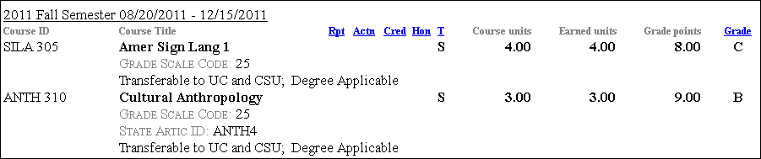

Rendering of possible transcript chage:
ANTH 310 | Cultural Anthropology |  |  |  |  | S | 3.00 | 3.00 | 9.00 | B
 | C-ID Designator/Descriptor: ANTH 120 Introduction to Cultural Anthropology
C-ID Descriptor Approval Date: June 15, 2010
COR Effective Term: Summer 2011

eTransCA_CO2010-04_DownloadOneTranscriptPerFile_Issue2288

Problem Statement

Currently the college transcripts are generated as a single PDF file with multiple transcripts. Because of this limitation, College users are not able to transfer the transcripts into their document management systems without creating internal PDF separation. Individual student transcripts cannot be identified without opening and searching the file.

Solution Request
See Xap proposal document – “Multiple Transcript PDF Files - Feature Description Document 20050724”
1) Transfer the PDF files into their document imaging system, thus streamlining this process and helping improving efficiency and productivity.
2) Electronically file the college transcripts in a more organized manner.
3) Search through their college transcript files more efficiently and faster.

eTransCA_CO2011-01_ DeleteExpiredTranscript_Issue2326_v1-3

Problem Statement
Currently, the transcript data sent via eTranscriptCA cannot be deleted or purged by the subscribing colleges. Subscribers can set their Control Center Preferences to expire Transcripts so transcripts can no longer be viewed online or downloaded but the transcript data continues to reside in the eTranscriptCA / Xap database. Expiration does not equal deletion. This poses a problem for many colleges that have retention policies stating they must delete transcript records after their internal specified time frame (e.g., 365 days).
Recent college, state and federal studies have highlighted an increasing emphasis on limiting the collection and retention of Social Security Numbers. The California College and University Social Security Number Task Force published a report in July 2010 outlining steps to reduce collection and retention of SSN data. In eTranscriptCA, along with the student academic data, the system stores personal indentifying information that needs to be managed and protected. In addition to being stored with the Transcript data, the student name, date of birth, and SSN are also stored with the other transactions (Requests, Response, and Transaction History). Currently this data remains available for viewing online for many years.

Solution Request
Add a new feature to eTranscriptCA that will run automatically and unattended to delete Transcript data and related transactions (requests and response) after the Transcript has been marked as Transcript Expired within the system.
This feature would run at least nightly and delete all Transcript, Request and Response data from the eTranscriptCA and Xap databases for all the Transcript records that have been marked as Transcript Expired. Deleted records would be purged from the Xap active databases with no reclamation of records. Expired / Purged eTranscriptCA transcript data would not be saved to Xap archive servers.
For all deleted Transcript records the Student Information (DOB, SSN, Student email, and School ID) contained within the Transaction History would be deleted as well. Student Information portion of Transaction History would retain Student Name, Transcript Institution, and Recipient Institution. The Transcript Transaction History portion would retain all the action history, date stamps, and notes.
If Transcripts are not marked as Expired then the data will remain on the system and retain the attributes of being viewable and downloadable on demand by authorized users.
Complete change order spec is available.

